Hospital Supply Chain Pick Ticket Analysis Report

Introduction
Effective supply chain management is essential in a hospital setting to ensure that medical staff have timely access to necessary supplies while maintaining operational efficiency. This report analyzes pick ticket data across four key areas: number of pages per room, number of lines per room, number of pages per employee, and number of lines per employee. Based on the dataset, weekly totals such as 39 pages, 11 pages, and 17 pages were observed, with a daily average of approximately 7.8 pages, indicating moderate but variable supply demand. By evaluating these sections, the goal is to identify patterns in supply demand, assess workload distribution, and recommend improvements to enhance efficiency and reduce operational waste.

Analysis of Pick Ticket Data by Room

Number of Pages of Pick Tickets for Each Room
The number of pages per room represents the overall volume of supply requests generated for each hospital area. In the dataset, rooms such as the Operating Room (OR) showed higher activity levels, with values reaching up to 8 pages in a single day, while other departments like ACU/PACU averaged around 5–6 pages, and ANES showed lower or inconsistent values.
These differences suggest that the OR is a high-demand department requiring frequent restocking, while other areas experience more variable or lower supply needs. Additionally, variation in page counts across rooms may indicate inconsistencies in ordering practices, suggesting an opportunity to streamline and standardize how supply requests are generated. Departments with consistently higher page counts should be prioritized for process improvements such as pre-stocked supply systems or standardized ordering procedures.

Number of Lines of Pick Tickets for Each Room
The number of lines per room provides a more detailed measure of demand by capturing the total number of individual supply items requested. While page counts ranged from 11 to 39 pages per week, the actual workload is better reflected through line counts, which represent individual supply items.
Rooms with higher implied line counts (based on higher page totals) likely experience more complex and resource-intensive orders. For example, a weekly total of 39 pages suggests significantly higher item demand compared to weeks with 11 pages, indicating variability in hospital activity or patient volume. This variation highlights the importance of tracking item-level demand to better manage inventory, reduce stockouts, and prevent over-ordering.

Analysis of Workforce Productivity

Number of Pages Pulled by Each Person
The number of pages pulled per employee reflects how work is distributed among staff. Based on the dataset’s weekly totals (e.g., 39 total pages in one period), workload distribution can vary depending on staffing levels and scheduling.
However, because page counts do not reflect the number of items per page, this metric alone may create misleading conclusions. For example, two employees handling the same number of pages may still experience significantly different workloads depending on the number of items per page. As a result, relying solely on page counts for performance evaluation or task assignment may lead to imbalances in workload and reduced efficiency.

Number of Lines Pulled by Each Person
The number of lines pulled per employee is the most accurate measure of workload and productivity. Although specific line totals are not clearly structured in the dataset, the variation in page counts (ranging from daily values of 4 to 10 pages) suggests fluctuations in actual item-level workload.
Employees working on higher-volume days (e.g., 10 pages in a single day) likely handled significantly more items than those working on lower-volume days (e.g., 4 pages). This reinforces the need to evaluate performance using line-based metrics rather than page counts alone. Tracking lines per employee would allow for more precise workload balancing, improved productivity assessment, and identification of inefficiencies in the picking process.

Integrated Findings and Key Insights
When analyzing all sections together, several key insights emerge from the data:
First, there is noticeable variability in supply demand, with weekly totals ranging from 11 to 39 pages and daily values fluctuating between 4 and 10 pages. This suggests inconsistent demand patterns, likely influenced by patient volume or departmental needs.
Second, high-demand areas such as the Operating Room (OR) consistently generate more pick ticket activity, indicating a need for targeted supply chain optimization in these departments.
Third, an important factor influencing daily workload variability is the difference in scanning frequency across departments. While high-volume areas such as the OR and Emergency Room (ER) are scanned daily, lower-volume areas such as ANES and 3N-MS are only scanned approximately twice per week. This difference not only affects daily workload distribution but also reveals an opportunity to optimize how often supplies are pulled.
Analysis of lower-frequency areas such as ANES shows that demand can be effectively managed with fewer scans, suggesting that not all departments require frequent restocking. Instead of simply redistributing scanning days, these trends indicate that hospitals can intentionally reduce the number of pulls for certain rooms by increasing inventory levels or adjusting reorder timing. This would minimize unnecessary picking activity and reduce overall workload without negatively impacting supply availability.
For example, rather than scanning a room multiple times per week, supply needs can be anticipated and fulfilled in fewer, more efficient pulls. This reduces repeated labor, improves efficiency, and allows staff to focus more on high-demand areas.
Finally, the gap between page-based metrics and actual workload highlights a limitation in the current tracking system. While pages provide a general overview, they do not accurately reflect the number of items handled, which is critical for measuring efficiency. Additionally, inconsistencies and missing data points suggest opportunities to improve data tracking and reporting accuracy.

Data Visualization and Interpretation
Graphical analysis of the dataset further supports these findings. Weekly totals demonstrate clear fluctuations in supply demand across different time periods. These variations indicate that hospital workload is not constant and must be managed dynamically.
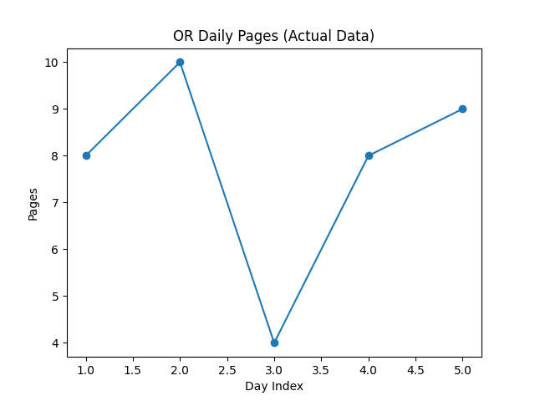
Daily visualization of the OR data shows values of 8, 10, 4, 8, and 9 pages, confirming that even high-volume departments experience day-to-day variability. However, because the OR is scanned daily, its workload remains relatively consistent compared to lower-frequency areas.
These visual trends reinforce that workload variability is driven both by operational demand and scanning frequency. This supports the need for both better workload balancing and strategic reduction of unnecessary supply pulls to improve efficiency.

Predictive Analytics for Supply Chain Optimization
In addition to analyzing historical data, predictive analytics can be used to forecast future supply chain workload. Time series forecasting models, such as exponential smoothing, are well-suited for this dataset because they analyze trends over time and generate predictions based on past behavior.
Using the OR data (8, 10, 4, 8, 9 pages), the forecasting model predicts future daily demand to fall within a range of approximately 7 to 9 pages. To improve accuracy, the model incorporates business-day date ranges, excluding weekends since supply chain operations do not occur on those days. This ensures that predictions align with real working conditions and avoids distortion of demand estimates.
For lower-frequency areas such as ANES, predictive models reveal a distinct pattern, with minimal or zero demand on non-scan days and moderate spikes on scheduled scan days. This pattern indicates that demand in these areas is predictable and does not require frequent intervention. By analyzing these trends, hospitals can identify opportunities to reduce the number of supply pulls by increasing order quantities per scan and extending the time between scans.
Predictive modeling therefore not only forecasts demand but also supports strategic decision-making regarding how often supplies should be pulled. This allows organizations to shift from reactive restocking to a more efficient, planned approach that reduces unnecessary labor while maintaining adequate inventory levels.

Recommendations for Supply Chain Improvement
Based on the analysis and observed data patterns, the following improvements are recommended:
- Adopt Line-Based Work Allocation
Transition from page-based to line-based workload tracking to ensure a more accurate and fair distribution of tasks.
- Reduce Pull Frequency Using Demand Trends
Instead of simply redistributing scanning schedules, hospitals should analyze demand patterns in lower-volume areas such as ANES to determine whether supply pulls can be performed less frequently. Data shows that these areas do not require daily attention and can operate effectively with fewer restocking cycles.
By increasing the quantity of supplies delivered per pull and extending the time between scans, the number of times staff must retrieve supplies for a room can be reduced. This minimizes repeated labor, decreases workload spikes, and improves overall efficiency. Additionally, reducing unnecessary pulls allows staff to focus more time and resources on high-demand areas such as the OR, where frequent restocking is essential.
- Implement Par-Level Inventory Systems
High-demand areas such as the OR (with up to 8 pages per day) should maintain pre-stocked supplies to reduce repeated picking.
- Improve Data Tracking Consistency
Address missing or inconsistent data entries to ensure more reliable analysis.
- Optimize Storage Layout
Place high-frequency items closer together based on demand patterns.
- Use Predictive Forecasting for Planning
Leverage time series models to anticipate demand and align staffing and inventory accordingly.

Conclusion
This analysis demonstrates that while page-based metrics provide a general overview of supply activity, they do not fully capture the complexity of hospital supply chain operations. The observed data, including weekly totals ranging from 11 to 39 pages and daily averages around 7.8 pages, highlights variability in demand and the impact of scanning frequency on workload distribution.
By shifting toward line-based metrics, optimizing inventory strategies, and leveraging demand trends to reduce unnecessary supply pulls in lower-volume areas, hospitals can significantly improve efficiency and reduce operational strain. Incorporating predictive analytics further enhances this approach by enabling proactive decision-making. These improvements ultimately lead to better resource management and enhanced patient care outcomes.

